Draft Rankings

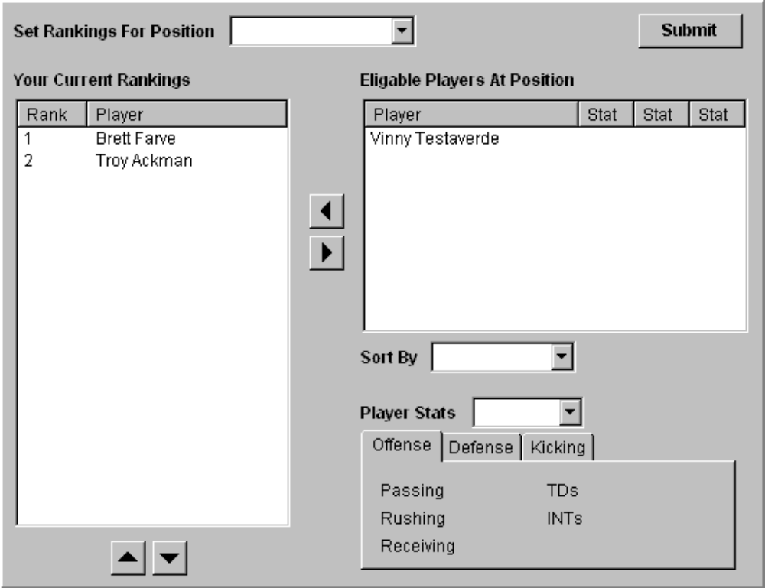

Notes:
- Set Rankings For Position will contain: Quarterbacks, Wide Recievers, Running Backs, Tight Ends, Kickers, Defense
- Sort By will contain: Player Name, Passing Yards, Receiving Yars, Running Yards, Touchdowns, etc.
- Player Stats will contain: Last Year, YTD, Career, etc.

Ideas:
- Eligable Players List will show different stats based on Position.
- Have option to specify what stats are shown in list.
-

Draft Salary Caps

Notes:

Ideas:

Draft Results

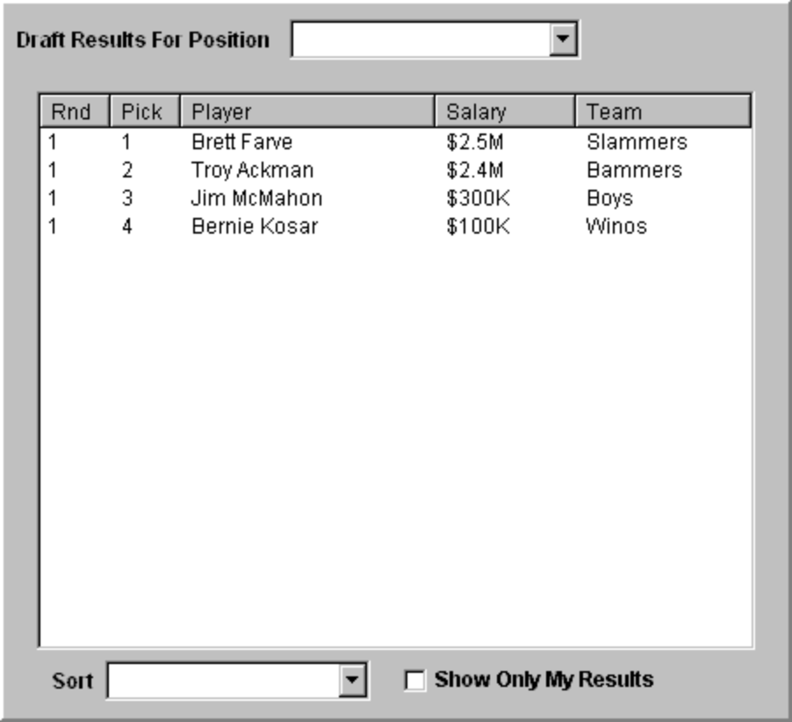

Notes:
- Draft Results for Position contains Quarterbacks, Wide Recievers, Running Backs, Tight Ends, Kickers, Defense, All Players.
- Pick is draft order relative to round.
- Sort By contains: Round/Pick, Player Name, Salary/Round/Pick, Team/Round/Pick
- Show Only My Results will only show players for your team.

Ideas:
- Round could be changed to Position

Schedule

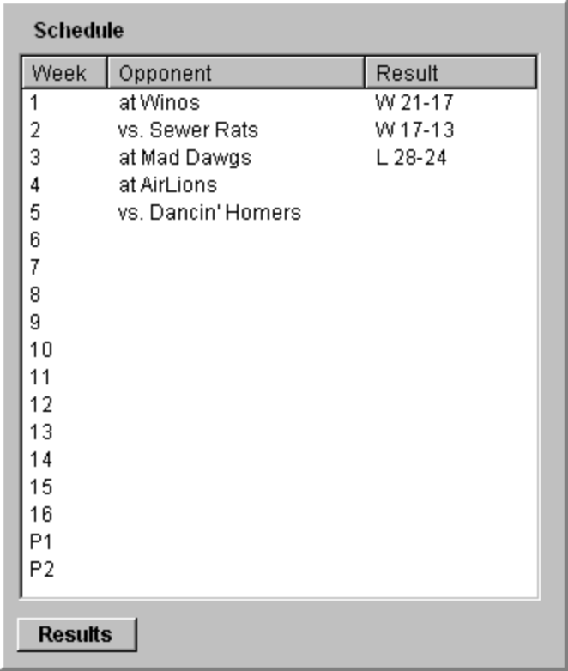(Alternate Idea)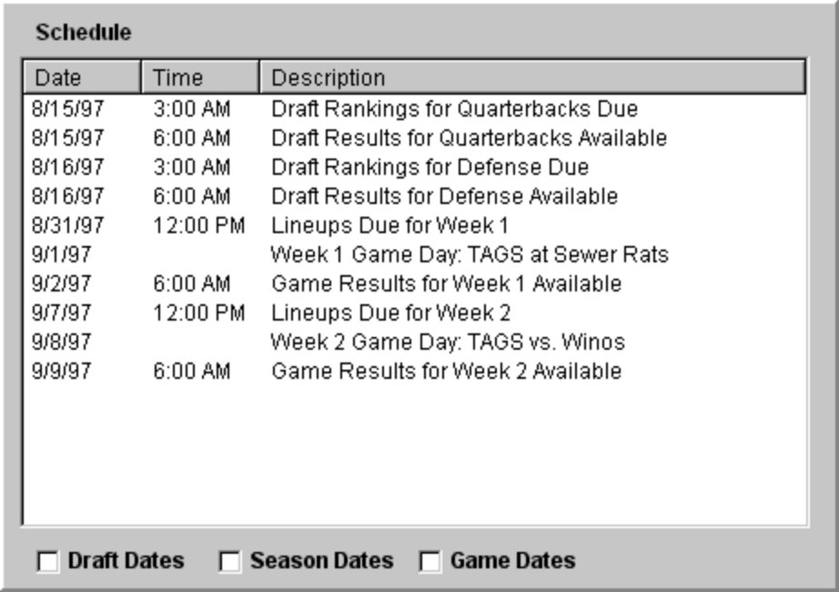

Notes:

Ideas:

Lineup

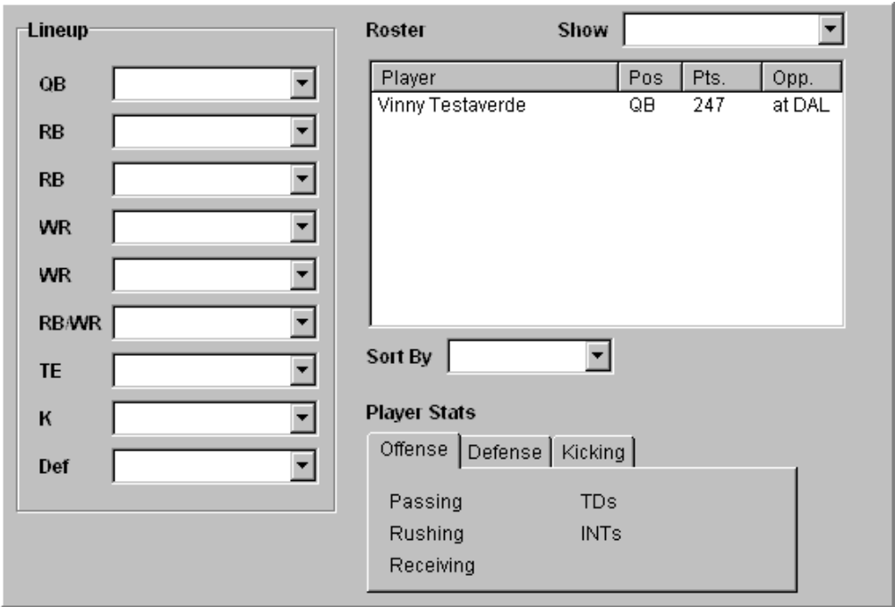

Notes:

Ideas:

Game Results

Notes:

Ideas:

League Standings

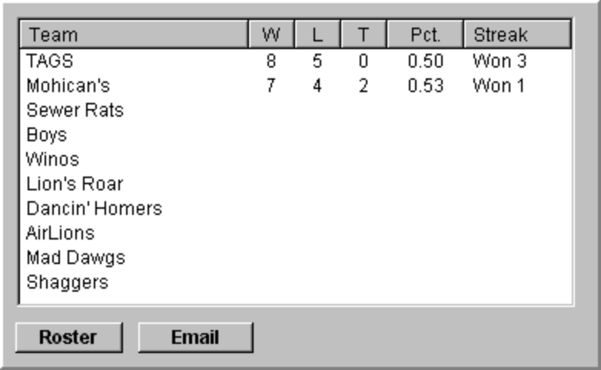

Notes:

Ideas:

League Leaders

Notes:

Ideas:

Team Stats

Notes:

Ideas:

Player Stats

Notes:

Ideas:

Free Agent Claims

Notes:

Ideas:

Trades

Notes:

Ideas:

Recent Transactions

Notes:

Ideas:

